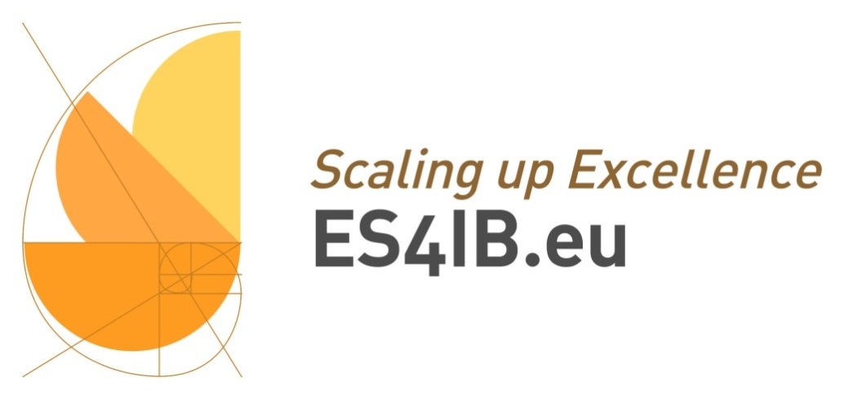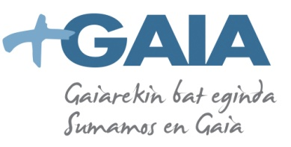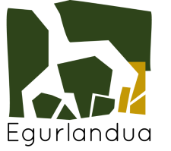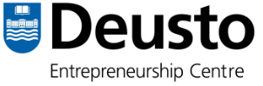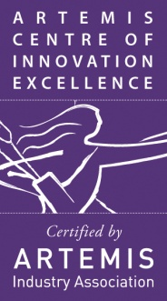

**Scaling up from projects to products and services**

**ARTEMIS CoIE WORKSHOP**

**Bilbao, 24th June**

Are you interested in **embedded systems**? Would you like to know how to identify opportunities and **challenges** related to eco-innovation, collaboration and market in European Platforms like **Artemis**?

If you would like to learn about real cases of **Project results’ exploitation to introduce new products and services into the market** while involving European SMEs, you should find out about ES4IB.eu in the Artemis CoIE Workshop. On the **24th of June at the University of Deusto**, you will have an excellent opportunity to network and share experiences about **strategies to promote sustainable value and responsibility for innovation in SMEs**. Framed in the **European Union – Sustainable Energy Week** (EUSEW), the event will include energy suppliers, universities, research institutes, SMEs, large business, administration, innovation managers, etc.

**AGENDA**

**9,30h Welcome. Representatives from the Basque Government and the University of Deusto.**

**10,00h ES4IB CoIE: an example of excellence in the scaling up of projects to markets thanks to ARTEMIS projects like eDiana.**

*Sr. Jokin Garatea, Director of the International Projects Department at GAIA*

ES4IB aims, among other things, to promote sustainable added value and innovation of SMEs. It is a contributor and co-creator of new business models to introduce products and services in the market from the participation of European SMEs.

ES4IB provides support to the R&D through commercialization and on the basis of a Living Lab methodology, a system for building a future economy in which the technique of co-creation is focused on real life user as a method of research and innovation. ES4IB is organized through co-location centres, being ESKILARA LAB one of them.

**10,30h. Arrowhead Case. How a R&D project can benefit from a Centre of Innovation and Excellence like ES4IB.eu.**

*Sr. Leire Bastida, TECNALIA.*

Example of mutual benefit between a R&D International Project like Arrowhead, oriented towards cooperative automation, and a Center of Innovation and Excellence like Embedded Systems for Intelligent Buildings, ES4IB.eu.

**11,00h. ESKILARA Lab. The co-location center which provides outreach services.**

*Sra. Surbhi Sharma, Spanish Honorary Consul in Bangalore (to be confirmed)*

Eskilara Lab is an accelerator for open innovation as a think tank for action. This is an excellent case in which the transfer of results to inclusive innovation projects promotes the development of new products and services for the generation of employment and entrepreneurship.

The European project Solar Design and Sustainable Integration Awards are two reference cases implemented in Eskilara Lab.

**11,30h. Solar Design Project. A case of success of the innovation process in the implementation of thin film solar cells in intelligent buildings.**

*Sra. Idoia Muñoz, Responsible for dissemination of the project*

Development of new materials, new manufacturing processes and support measures to improve communication in the value chain of the solar cell design.

Integration of thin-film solar cells will be conducted in Solar Design project though three different pilots: a textile to create a solar fabric and thin-film integration in electronics and street lamps.

**12, 00h. Sustainable Integration Awards. Eco Sustainable Wood Competition.**

*Sr. Asier Arrizabalaga, Comercial technical responsible at Egurlandua*

The competition is aimed at rewarding contributions that have a high value of innovation and conceptual research on the subject proposed: young, design, wood and sustainable technological hybridization.

The work done by the participants will be exhibited at the conference and names of the winners will also be reveal.

**Interested in signing up to the Workshop, via email to:**

**IDOIA MUÑOZ**

**idoia@gaia.es**

