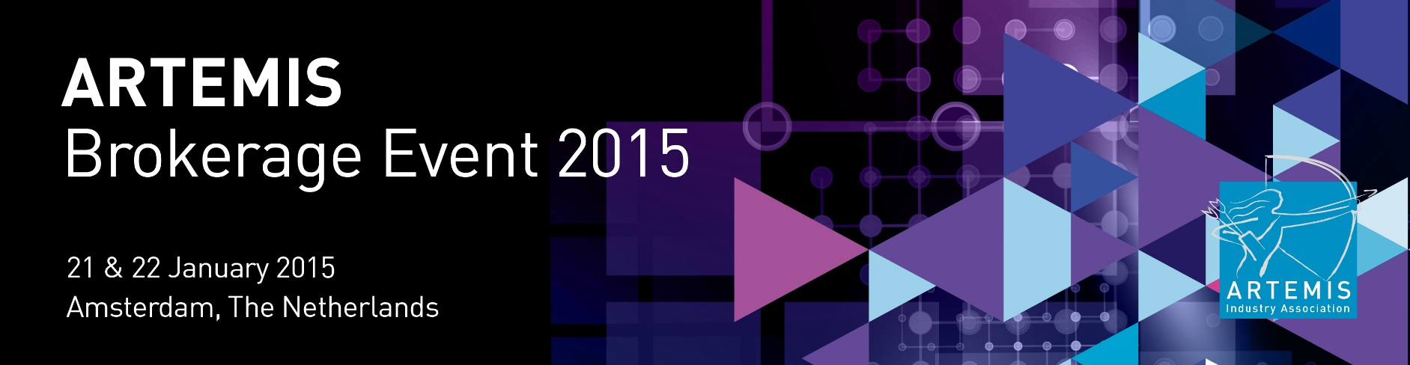

**PROJECT TITLE / ACRONYM**   
**P**roject **T**itle **Ex**plaining **A**cronym If Necessary

**POSTERSIZE A1 max!  
[84.1cm*59.4cm]**

**PROJECT IDEA**

This is part on the poster is for a short summary and information about your project idea. Use about 150 and 225 words in maximum. Most importantly is to present what you can offer a **research consortium**. There is often a tendency to present only the financials or business turnover of a particular existing product or service. This is useful background, but a consortium is mostly interested what you can bring to a research organisation. Therefore it’s important **to focus on technologies and other in-house know-how,** to develop further or **focus on services** you can offer and what realistically can be expected to go to market in between 2 to 5 years.

**Add a keen image or graphic on the right >>>>**

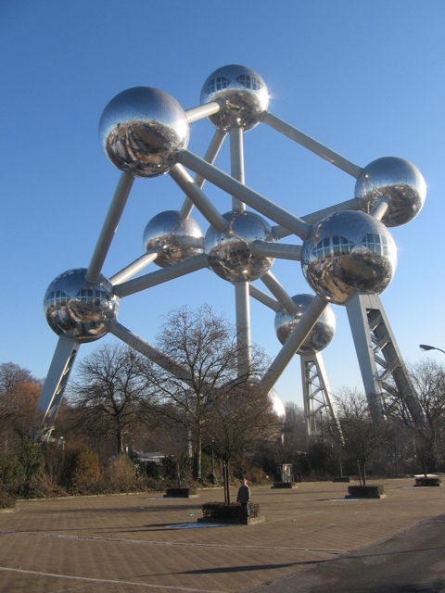

**ADDITIONAL INFORMATION**

Make sure your poster contains the following information:

* + > Project Name
  + > Small Summary
  + > Unique Selling Points (3 to 5)
  + > Existing Partners
  + > Required Partners / Expertises
  + > Contact details (name, email, mobile number)
  + > Images (if possible)
  + **IMPORTANT**
  + Participants don’t sign a Non-Disclosure Agreement. So please be careful with your information. We advise you to take an informative/clear poster, without going too much into the technical details. This is your own responsibility.

CONTACT PERSON   
> Name of contact person   
> Mobile number   
  
ORGANISATION   
> Organisation name   
  
CONSORTIUM STATUS   
> Status of consortium  
> Status of consortium

AVAILABLE KEY PARTNERS   
> Available key partners   
> Available capabilities

MISSING PARTNERS   
> Missing partners   
> Missing capabilities